10.66: The accelerations of blocks A and B will have the same magnitude a. Since the cord does not slip, the angular acceleration of the pulley will be 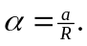 Denoting the tensions in the cord as 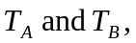 the equations of motion are

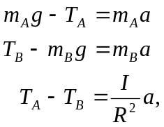

where the last equation is obtained by dividing 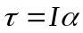 by R and substituting for in terms of a.

Adding the three equations eliminates both tensions, with the result that
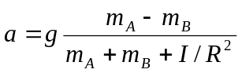
Then,
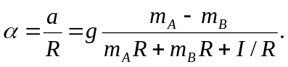
The tensions are then found from

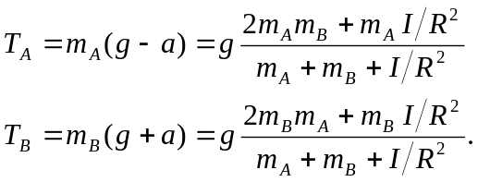

As a check, it can be shown that 